Deployment logs



kubectl get pods

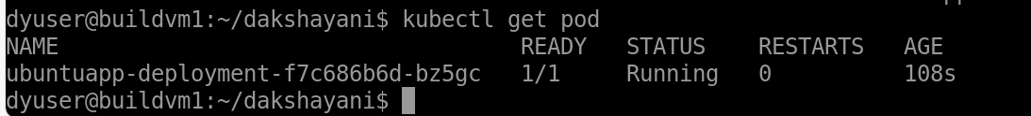

kubectl describe.

